**PPS Assignment-III**

# **Uppala B Archana**

# **B181867**

### **1)) Implement the following Searching Techniques.**

### **a) Linear search**

**1.Problem statement**

Implement the searching Technique of linear search.

**2.Pseudo code/ flow chart**

Int Linear search(int[] list, int target)

For(int j=0;j<list.length ; j=j+1)

If(list[j]==target)

Return j

End if

End for

Return -1

End linear search

**3.C program**

# include <stdio.h>

int main()

{

    int i,data,a[50],size;

    printf("enter the size of array");

    scanf("%d",&size);

    if(size>50)

    {

        printf("overflow condition");

    }

    else

    {

    printf("enter elements of array:\n");

    for(i=0;i<size;i++)

    {

        scanf("%d",&a[i]);

    }

    printf("enter the element you want to search in the array:");

    scanf("%d",&data);

    for(i=0;i<size;i++)

    {

        if(a[i]==data)

        {

            printf("element found at index:%d",i);

            break;

        }

    }

    if(i==size)

    {

        printf("element not found");

    }

    }

    return 0;

}

**4. Results (min: 3 IN/OUT)**

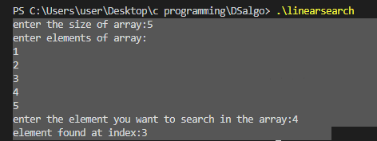

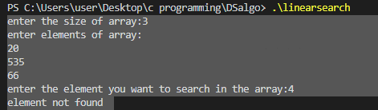

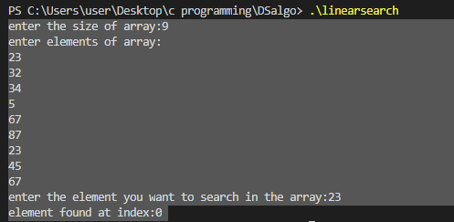

**5. Observations**

**Linear search algorithm will search for the every element that is equal to the entered data element and return the index if found.**

### **b) Binary search**

**1.Problem Statement**

Implement the searching Technique of binary search.

**2.Pseudo code/ flow chart**

Binary_search(a.n,key)

Begin

Set start=0,end=n-1,mid=(start+end)/2;

While (start<=end && a[mid]!=key) do

If(key<a[mid] then

Set end=mid-1;

Else

Set end=mid+1;

End if

Set mid=(start+end)/2;

End while

If (start+end)

Return -1;

Return mid;

End

**3.C program**

# include <stdio.h>

int Binarysearch(int a[],int size,int element);

int main()

{

    int i,data,a[50],size,result;

    printf("enter the size of array");

    scanf("%d",&size);

    if(size>50)

    {

        printf("overflow condition");

    }

    else

    {

    printf("enter elements of array:\n");

    for(i=0;i<size;i++)

    {

        scanf("%d",&a[i]);

    }

    }

    printf("enter the element you want to search in the array:");

    scanf("%d",&data);

    Binarysearch(a,size,data);

     printf("%d is found at Index %d \n",data,Binarysearch(a,size,data));

    return 0;

}

int Binarysearch(int a[],int size, int data)

    {

        int l=0,r=size-1;

        int mid;

        while(l<r)

        {

            mid=(l+r)/2;

            if(data==a[mid])

            return mid;

            else if (data<a[mid])

            r=mid-1;

            else

            l=mid+1;

        }

        return -1;

    }

**4. Results (min: 3 IN/OUT)**

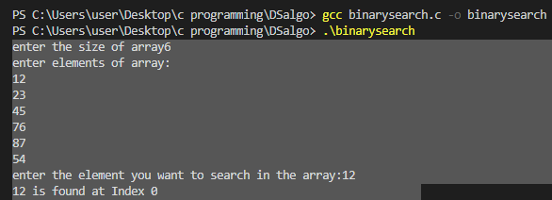

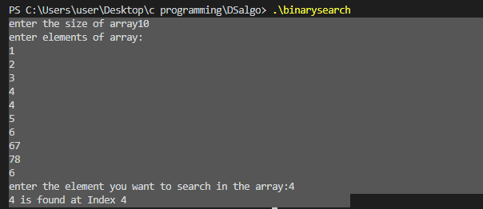

**5. Observations**

* **It is important to define the type of elements that we use in the function definition. Even if it is the array.**

### **2) Implement the following Sorting Techniques.**

### **a) Bubble sort**

**1.Problem statement**

**Implement the Bubble sort sorting technique**

**2.Pseudo code/ flow chart**

**Begin Bubble sort(list)**

**For all elements of list**

**If list[i]>list[i+1]**

**Swap(list[i],list[i+1])**

**End if**

**End for**

**Return list**

**End Bubble sort**

**3.C program**

# include <stdio.h>

int main()

{

    int i,j,a[50],n,temp;

    printf("enter the size of array");

    scanf("%d",&n);

    if(n>50)

    {

        printf("overflow condition");

    }

    else

    {

    printf("enter elements of array:\n");

      for(i=0;i<n;i++)

      {

          scanf("%d",&a[i]);

      }

     for(i=0;i<n-1;i++)

     {

         for(j=0;j<n-1-i;j++)

        {

            if(a[j]>a[j+1])

            {

                temp=a[j];

                a[j]=a[j+1];

                a[j+1]=temp;

             }

        }

     }

     printf("The sorted array by the bubble sort is:\n");

     for(i=0;i<n;i++)

     {

         printf("%d\t",a[i]);

     }

    }

  return 0;

}

**4. Results (min: 3 IN/OUT)**

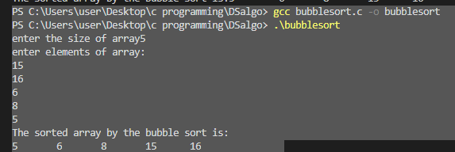

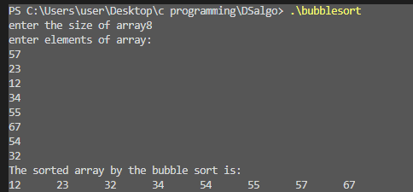

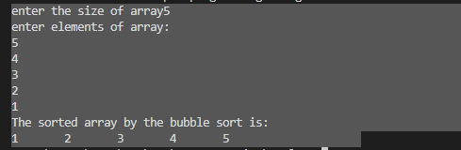

**5. Observations**

* The main condition is if(a[j]>a[j+1]) to check in the bubble sort

### **b) Insertion sort**

**1.Problem statement**

**Implement the Insertion sort sorting technique**

**2.Pseudo code/ flow chart**

**Procedure Insertion sort(A)**

**Int hole position**

**Int value to insert**

**For i=1 to length(A) do:**

**value to insert=A[i]**

**hole position i**

**while hole position>0 and A[hole position-1]>value to insert**

**A[hole position]=A[hole position -1]**

**hole position - -**

**end while**

**end for**

**end procedure**

**3.C program**

# include <stdio.h>

int main()

{

    int i,j,data,a[50],size ,temp;

    printf("enter the size of array");

    scanf("%d",&size);

    if(size>50)

    {

        printf("overflow condition");

    }

    else

    {

    printf("enter elements of array:\n");

    for(i=0;i<size;i++)

    {

        scanf("%d",&a[i]);

    }

    printf("elements in array are:\n");

     for(i=0;i<size;i++)

     {

         printf("%d\t",a[i]);

     }

    for(i=1;i<size;i++)

    {

        temp=a[i];

        j=i-1;

        while(j>=0 && a[j]>temp)

        {

            a[j+1]=a[j];

            j--;

        }

        a[j+1]=temp;

    }

    printf("\nthe sorted array by insertion sort is:\n");

     for(i=0;i<size;i++)

     {

         printf("%d\t",a[i]);

     }

    }

    return 0;

}

**4. Results (min: 3 IN/OUT)**

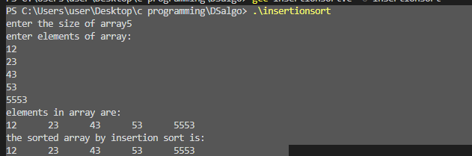

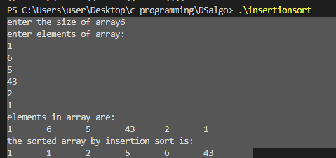

**5. Observations**

* **Insertion sort divides the array into subarray one as sorted subarray and the other as unsorted subarray.**
* **The sorted subarray contains one element at first.**

### **c) Selection sort**

**1.Problem statement**

**Implement the Selection sort sorting technique**

**2.Pseudo code/ flow chart**

**Procedure Selection sort**

**List : array of items**

**n : size of list**

**for i=1 to n**

**min=i**

**for j=i+1 to n**

**if list[j]<list[min] then**

**min=j**

**end if**

**end for**

**if indexmin!=I then**

**swap list[min] and list[i]**

**end if**

**end for**

**end procedure**

**3.C program**

# include <stdio.h>

int main()

{

    int i,j,data,a[50],size ,temp;

    printf("enter the size of array");

    scanf("%d",&size);

    if(size>50)

    {

        printf("overflow condition");

    }

    else

    {

    printf("enter elements of array:\n");

    for(i=0;i<size;i++)

    {                                      //to take input from user

        scanf("%d",&a[i]);

    }

    printf("elements in array are:\n");

     for(i=0;i<size;i++)

     {                                       // to output the initial array

         printf("%d\t",a[i]);

     }

     for(i=0;i<size-1;i++)

     {

         int min=i;

         for(j=i+1;j<size;j++)

         {

             if(a[j]<a[min])

             min=j;

         }

         if(min!=i)

         {

             temp=a[min];

             a[min]=a[i];

             a[i]=temp;

         }

     }

    printf("\nthe sorted array by selection sort is:\n");

     for(i=0;i<size;i++)

     {

         printf("%d\t",a[i]);

     }

    }

    return 0;

}

**4. Results (min: 3 IN/OUT)**

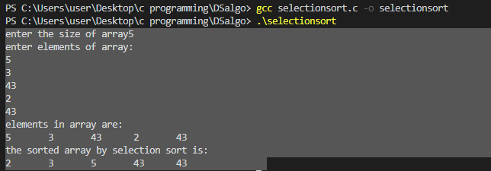

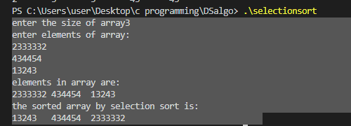

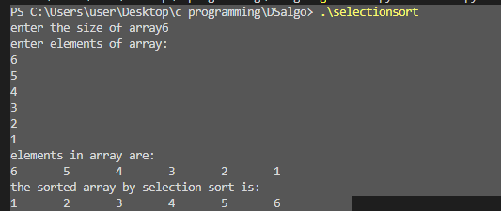

**5. Observations**

* **Selection sort divides the array into subarray one as sorted subarray and the other as unsorted subarray.**
* **The sorted subarray is empty here in selection sort.**

### **d) Quick sort(using recursion)**

**1.Problem statement**

**Implement the Quick sort sorting technique using recursion.**

**2.Pseudo code/ flow chart**

**Quick sort( arr ,beg ,end)**

**If(beg<end)**

**Pivot index=position(arr,beg,end)**

**Quick sort(arr ,beg , pivotindex)**

**Quick sort(arr,pivotindex+1,end)**

**Partition(arr ,beg,end)**

**Set end as pivot**

**Pindex=beg-1**

**For i=beg to end-1**

**If arr[i]<pivot**

**Swap arr[i] and arr[pindex]**

**Pindex++**

**Swap pivot and arr[pindex+1]**

**Return pindex+1**

**3.C program**

# include <stdio.h>

int partition(int [],int ,int);

int quicksort(int[],int, int);

int  partition(int a[25],int lb,int ub)

{   int pivot,start,end,temp;

     pivot=a[lb];

     start=lb;

     end=ub;

     while(start<end)

     {

         while(a[start]<=pivot)

         start++;

         while(a[end]>pivot)

         end--;

         if(start<end)

         {

             temp=a[start];

             a[start]=a[end];

             a[end]=temp;

         }

     }

     temp=a[lb];

     a[lb]=a[end];

     a[end]=temp;

     return end;

}

int quicksort(int a[25],int lb,int ub)

{    int loc ,count;

    if(lb<ub)

    {

        loc=partition(a,lb,ub);

        quicksort(a,lb,loc-1);

        quicksort(a,loc+1,ub);

    }

}

int main()

{

    int i,count,a[25];

    printf("how many numbers do you want to enter:");

    scanf("%d",&count);

    printf("enter %d elements:\n",count);

    for(i=0;i<count;i++)

    {

        scanf("%d",&a[i]);

    }

    quicksort(a,0,count-1);

    printf("order of sorted elements:\n");

    for(i=0;i<count;i++)

      printf("%d\t",a[i]);

    return 0;

}

**4. Results (min: 3 IN/OUT)**

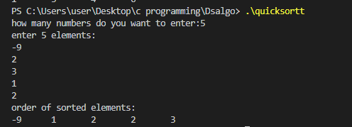

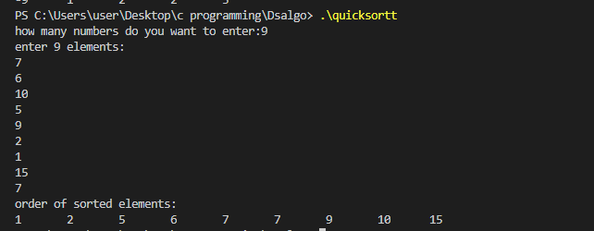

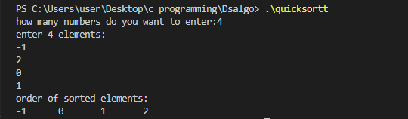

**5. Observations**

* **We are going to choose one pivot element.**
* **Pivot element can be anything.**
* **Partition the array in such a way that all the elements<pivots would be to the left side and all the elements>pivot would be to the right side of the pivot.**
* **Passing the arguments into the function should be taken care of..**

### **e) Merge sort(using recursion)**

**1.Problem statement**

**Implement the Merge sort sorting technique using recursion.**

**2.Pseudo code/ flow chart**

MergeSort(arr[],left,right)

If left>right

return

mid=(left+right)/2

MergeSort(arr,left,mid)

MergeSort(arr,mid,right)

End

**3.C program**

# include <stdio.h>

int merge(int[],int,int,int);

int mergesort(int[],int,int);

int mergesort(int a[25],int lb,int ub)

{   int mid;

    if(lb<ub)

    {

        mid=(lb+ub)/2;

        mergesort(a,lb,mid);

        mergesort(a,mid+1,ub);

        merge(a,lb,mid,ub);

    }

}

int merge(int a[25],int lb,int mid,int ub)

 {  int i,j,k,b[25];

    i=lb;

    j=mid+1;

    k=lb;

    while(i<=mid && j<=ub)

    {

      if(a[i]<=a[j])

      {

          b[k]=a[i];

          i++;

      }

      else

      {

          b[k]=a[j];

          j++;

      }

      k++;

    }

    if(i>mid)

    {

        while(j<=ub)

        {

            b[k]=a[j];

            j++;

            k++;

        }

    }

    else

    {

        while(i<=mid)

        {

            b[k]=a[i];

            i++;

            k++;

        }

    }

    for(k=lb;k<=ub;k++)

    {

        a[k]=b[k];

    }

 }

int main()

{

    int i,count,a[25];

    printf("how many numbers do you want to enter:");

    scanf("%d",&count);

    printf("enter %d elements:\n",count);

    for(i=0;i<count;i++)

    {

        scanf("%d",&a[i]);

    }

    mergesort(a,0,count-1);

    printf("order of sorted elements:\n");

    for(i=0;i<count;i++)

      printf("%d\t",a[i]);

    return 0;

}

**4. Results (min: 3 IN/OUT)**

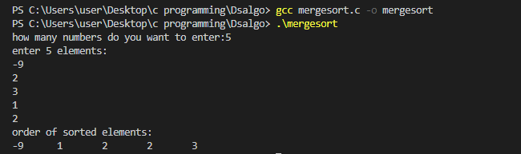

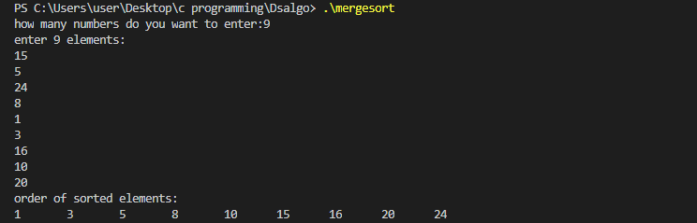

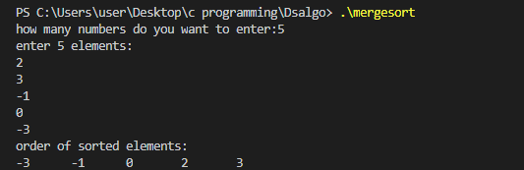

**5. Observations**

* **Complete array is divided into n sub arrays.**
* **Each subarray is having one element.**
* **We keep on dividing the array into subarray, until we get the subarray containing only one element.**
* **After that, we keep on merging the subarrays to produce a new sorted array**.